|  |  |  |  |
| --- | --- | --- | --- |
| |  |  | | --- | --- | |  | CCS3351 Mobile Application Development  Final project (100 marks) | |  |

### Instructions:

* If your SLTC student number ends with 0,1,2,3 then you must attempt question 1.
* If your SLTC student number ends with 4,5,6 then you must attempt question 2.
* If your SLTC student number ends with 7,8,9 then you must attempt question 3.
* Submit your answers as a single file (**.ZIP**) on or before the deadline provided in the LMS.
* Submission must include this document explaining your code, UI and lessons learnt
* Late submission will not be considered for the marking.
* Make sure to include this document in your submission

|  |  |
| --- | --- |
| Full name: |  |
| Student index: |  |
| Date of submission: |  |

## Q1. BMI calculator

BMI, or Body Mass Index, is a numerical value of a person's weight in relation to their height. It is a commonly used screening tool to categorize individuals into different weight status categories, such as underweight, normal weight, overweight, and obesity.

BMI is calculated using the following formula:

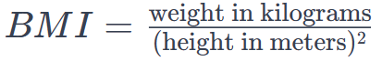Here's a breakdown of the BMI categories:

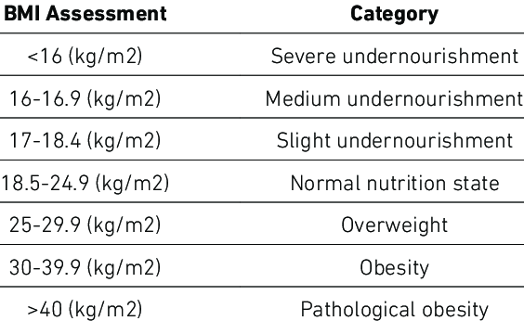Watch this video for more details: https://youtu.be/t8sIioCX0lk

### Requirements:

Write a flutter application to calculate BMI using Material UI and GetX.

1. It must have two screens, one to calculate BMI, another to show information about the category result.
   1. Calculate screen: It should have two input fields to receive height and weight, a button to calculate the BMI and a place to display the result (10 marks)
   2. Information screen: Display category info as per the calculated results. (10 marks)
   3. Navigation mechanism working (10 marks)
2. When the “Calculate” button is pressed it shows correct BMI value (5 marks)
3. When the user goto “Info” screen, it shows correct category information (5 marks)
4. Draw the widget hierarchy diagram (20 marks)
5. A section on the lessons learnt during this exercise (10 marks)
6. Generate DartDoc files (5 marks)
7. Upload your complete, commented, tested code as a Git Hub repository to /final branch. Include the link in the document (5 marks)
8. Viva (class presentation of working application – 20 marks)

## Q2. Blood pressure monitor

Your blood pressure is recorded as two numbers:

* Systolic blood pressure (the first number) – indicates how much pressure your blood is exerting against your artery walls when the heart contracts.
* Diastolic blood pressure (the second number) – indicates how much pressure your blood is exerting against your artery walls while the heart muscle is resting between contractions.

### Blood pressure categories

The five blood pressure ranges as recognized by the American Heart Association are:

#### 1. Normal

Blood pressure numbers of less than 120/80 mm Hg (millimeters of mercury) are considered within the normal range.

#### 2. Elevated

Elevated blood pressure is when readings consistently range from 120-129 systolic and less than 80 mm Hg diastolic.

#### 3. Hypertension Stage 1

Hypertension Stage 1 is when blood pressure consistently ranges from 130 to 139 systolic or 80 to 89 mm Hg diastolic.

#### 4. Hypertension Stage 2

Hypertension Stage 2 is when blood pressure consistently is 140/90 mm Hg or higher.

#### 5. Hypertensive crisis

This stage of high blood pressure requires medical attention.

Watch this video for more details: https://youtu.be/o8DX89jm710

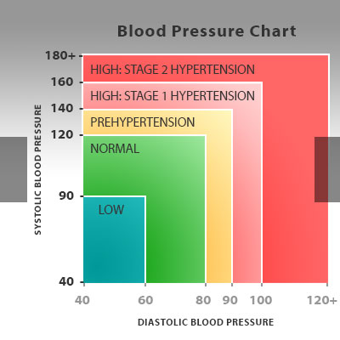

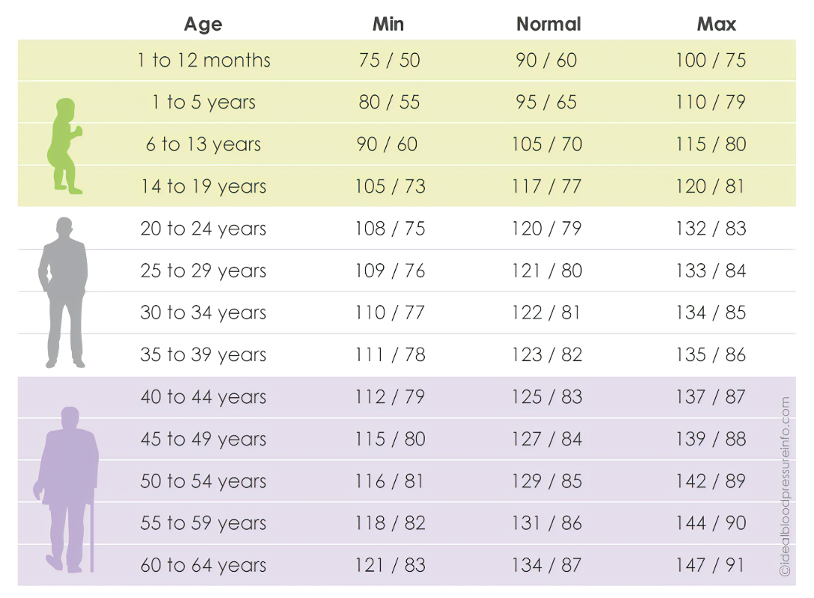Blood pressure shown as systolic/diastolic

### Requirements:

Write a flutter application to classify blood pressure readings using Material UI and GetX.

1. It must have two screens, one to input blood pressure data, another to show information about the category.
   1. Input screen: It should have two input fields to receive Systolic & Diastolic values, a button to validate the values and navigate to next screen to display the result. You may use an Alert show invalid data   
      (10 marks)
   2. Information screen: Display category info as per the input data. (10 marks)
   3. Navigation mechanism working (10 marks)
2. When the “Show info” button is pressed it goes to the correct screen (5 marks)
3. When the user goto “Info” screen, it shows correct category information (5 marks)
4. Draw the widget hierarchy diagram (20 marks)
5. A section on the lessons learnt during this exercise (10 marks)
6. Generate DartDoc files (5 marks)
7. Upload your complete, commented, tested code as a Git Hub repository to /final branch. Include the link in the document (5 marks)
8. Viva (class presentation of working application – 20 marks)

## Q3. Blood sugar monitor

Glucose comes from the food we eat and its sugar content. When a person consumes a food with high sugar content, that is turned into glucose. The glucose is then absorbed into the bloodstream with the support of insulin. This is then distributed between the body’s cells and used as energy.

Diabetes is a chronic health condition that occurs when the body is unable to properly regulate blood sugar (glucose) levels. According to the International Diabetes Federation (IDF) and the World Health Organization (WHO), diabetes was estimated to be responsible for around 4 million deaths globally in the year 2019.

This chart details goals for specific groups of people with diabetes.

|  |  |  |  |
| --- | --- | --- | --- |
|  | **Before meals (fasting)** | **After meals (postprandial)** | **Other** |
| Adults with type 1 & 2 diabetes | 80–130mg/dL | < 180 mg/dL and (1 or 2 hours after) |  |
| Children with type 1 diabetes | 90-130 mg/dL |  | 90–150 mg/dL at bedtime/overnight |
| Pregnant people (T1D, gestational diabetes) | < 95 mg/dL | 140 mg/dL (1 hour after) | 120 mg/dL (2 hours after) |
| 65 or older | 80–180 mg/dL |  | 80–200 mg/dL for those in poorer health, assisted living, end of life |
| Without diabetes | 99 mg/dL or below | 140 mg/dL or below |  |

* Watch this video for more details: <https://youtu.be/O7l3qg0Z4GE>
* <https://www.medicalnewstoday.com/articles/317536>

### Requirements:

Write a flutter application to classify blood sugar readings using Material UI and GetX.

1. It must have two screens, one to input blood suger data, another to show information about the category.
   1. Input screen: It should have two input fields to receive before & after blood glucose values, a button to validate the values and navigate to next screen to display the result. You may use an Alert show invalid data (10 marks)
   2. Information screen: Display category info as per the input data. (10 marks)
   3. Navigation mechanism working (10 marks)
2. When the “Show info” button is pressed it goes to the correct screen (5 marks)
3. When the user goto “Info” screen, it shows correct category information (5 marks)
4. Draw the widget hierarchy diagram (20 marks)
5. A section on the lessons learnt during this exercise (10 marks)
6. Generate DartDoc files (5 marks)
7. Upload your complete, commented, tested code as a Git Hub repository to /final branch. Include the link in the document (5 marks)
8. Viva (class presentation of working application – 20 marks)

# Paste the code here

You may post the architecture diagram here with a link to GitHub repo.

# Paste the UI here

Figma prototype and final Flutter UIs

# Lessons learnt